Triple Cities Ski Club
Presents
Ski Les Trois Vallées, FRENCH ALPS!
Stay in the Village of Val Thorens
March 7th – March 15th, 2025
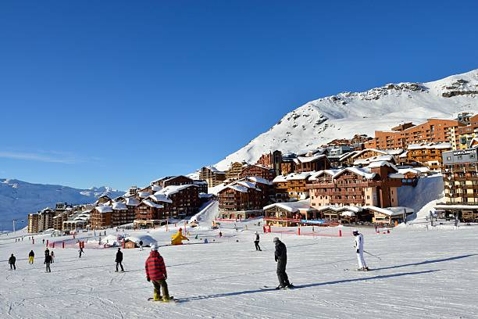
Approximately $3,040* - Per Person (Dbl. Occupancy) Using Epic Pass**

French Alps – Val Thorens Ski The Alps – Val Thorens

Join your TCSC friends on a fabulous European adventure! We will travel to Les Trois Vallées (The 3 Valleys), in the French Alps. Les Trois Vallées is the largest ski area in the world, offering breathtaking elevations, expansive ski areas, and 600 km (373 miles) of interconnected ski-slopes for all levels of skiers and snowboarders. Les Trois Vallées ski area consists of seven unique ski-in/ski-out resorts/villages, including Courchevel, Méribel, Brides-les-Bains, Les Menuires, Saint-Martin-de-Belleville, Val Thorens, and Orelle. It is internationally acclaimed for its immense size; in fact, it encompasses the five largest ski areas in the United States. The TCSC will be staying in the village of Val Thorens, which has enjoyed an international reputation that has transcended French and European boarders for over 60 years. Nearly 50% of the pistes are classified as green and blue. We will be staying at the Hotel Le Val Chaviere. In addition to the skiing, highlights of the region include views of Mont Blanc, the Vnoise massif, the Ecrins, the Beaufortain, the Lauziere and more!
Depart Endicott to JFK via bus the morning of March 7, 2025
Depart JFK, March 7, 2025, via Swiss, direct to Geneva
Bus transfer from Geneva Airport to Val Thorens, to the Hotel Le Val Chaviere, on March 8, 2025
Six days of skiing, Sunday-Friday, March 9th - 14th, 2025
Price includes:
- Round trip transfers via bus from Endicott to JFK.
- Round trip, non-stop flight from JFK to Geneva.
- Round trip transfers via bus from Geneva to Val Thorens.
- 7 nights lodging.
- Breakfast & dinner daily at the hotel.
- First bag flies free. The charge for the second bag is approximately $100 each way.

**No EPIC pass? Separate lift tickets range in price from approximately $365 age 65 – 74; $420 age 64 and under for a 6-day pass.
* Trip price may change subject to any new taxes or fees imposed by the government, airport, airlines, or agencies involved. TCSC and its agents have no control or responsibility over such increases.
* Trip Insurance is the participant’s responsibility.

The trip will go on sale Wednesday, April 10, 2024, at 7:00 PM on the club’s website.

LODGING:
All rooms accommodate 2 people. Please indicate the person you wish to be your roommate when registering online; otherwise, we will assign a roommate for you (same sex/gender).

RESERVATION REQUIREMENTS:
- You must be a member of TCSC to sign up for this trip. This trip will be open to other Eastern Pa. Ski Council Clubs 45 days after going on sale.
- Reservations are limited to 44 people. If reservations are full, please add your name to the waitlist.
- THIS TRIP MAY SELL OUT QUICKLY! Reservations will be accepted on a first-come, first-serve basis. Your reservation is NOT confirmed until we receive your deposit (check only). You will get a confirmed reservation email from the trip leaders when your check arrives.
- Deposit must be postmarked within 10 days of your online registration. Your deposit is fully refundable prior to September 1 should you choose not to participate in the trip.
- We will not accept any payments postmarked prior to the trip going on sale.
- If your deposit is not received or postmarked within the time limit, you may be moved to the waitlist.
- If your name is on the waitlist, you are not required to mail your deposit at this time. If your name gets moved from the waitlist and onto the trip, your deposit will be required within 5 days after notification by the trip leaders (the roommate replacement from the waitlist should be the same sex/gender).

HOW TO RESERVE YOUR SPOT ON THIS TRIP:
- Reservations begin Wednesday, April 10, 2024 at 7:00 p.m.
- Go to the club’s website at https://www.triplecitiesskiclub.com and click on the Members Only tab, Ski Trips, Ski Trip List.
- Select Les Trois Vallées Ski the French Alps and then select “RSVP”.
- Mail your $790 deposit check made out to “TCSC” to Steve Manning, 60 Crestview Drive East, Pine City, NY 14871 within 10 days of your online reservation.

PAYMENT SCHEDULE:
- Initial Deposit of $ 790 must be postmarked 10 days after your online registration.
- 2nd Payment of $750 is due July 15, 2024
- 3rd Payment of $750 is due September 5, 2024
- 4th Payment of $750 is due on November 7, 2024

Send all payments (checks only, made out to TCSC) to trip leader Steve Manning via U.S. mail (address below). You may pay for your trip in full at any time.

CANCELLATION CHARGES, FEES, AND REFUND POLICY:
- Cancel prior to September 1st, receive full refund.
- For any cancellations between September 1 – September 30, 2024, there will be a $50 non-refundable cancellation fee.
- After September 30, 2024, $500 becomes non-refundable.
- After December 26, 2024, the entire trip is non-refundable.
- The above may be negated if the cancelling party is replaced by a person from the waitlist.
- Name changes on airline tickets after they are issued (01/03/25) could cost up to $300 per ticket plus any rerouting charges from the airline.
- Other cancellation fees may apply.

Trip Leader:
Steve Manning
60 Crestview Drive
Pine City, NY 14871
607-738-1284
smmanning3@outlook.com
Trip Leader:
Peter Punzo
4818 Lepinske Farm Place
Clay, NY 13041
607-731-1597
ppunzo@gmail.com

